Binomial:

A polynomial equation with two terms usually joined by a plus or minus sign is called a binomial. Binomials are used in algebra. Polynomials with one term will be called a monomial and could look like 7x. A polynomial with two terms is called a binomial; it could look like 3x + 9. It is easy to remember binomials as **bi**means 2 and a binomial will have 2 terms.

A classic example is the following: 3x + 4 is a binomial and is also a polynomial,  2a(a+b) 2is also a binomial (a and b are the binomial factors).

The above are both binomials.

When multiplying binomials, you'll come across a term called the [FOIL method](https://www.thoughtco.com/exercise-worksheets-using-foil-2312026) which is often just the method used to multiply binomials.

For instance, to find the product of 2 binomials, you'll add the products of the **F**irst terms, the **O**uter terms, the **I**nner terms, and the **L**ast terms.

When you're asked to square a binomial, it simply means to [multiply](https://www.thoughtco.com/tricks-to-learn-the-multiplication-facts-2312460) it by itself. The square of a binomial will be a trinomial. The product of two binomials will be a trinomial.

Example of Multiplying Binomials

(5 + 4x) x (3 + 2x)  
(5 + 4x)(3 + 2x)  
= (5)(3) + (5)(2x) + (4x)(3) + (4x)(2i)  
= 15 + 10x + 12x + 8(x)2 = 15 + 22x + 8(-1)  
= 15 + 22x - 8 = (15 - 8) + 22x = 7 + 22x

Once you begin taking algebra in school, you'll be doing a great many computations that require binomials and polynomials.

The formal expression of the Binomial Theorem is as follows:

(a + b)^n = sum[k=0,n][(n over k)a^(n-k)b^k]

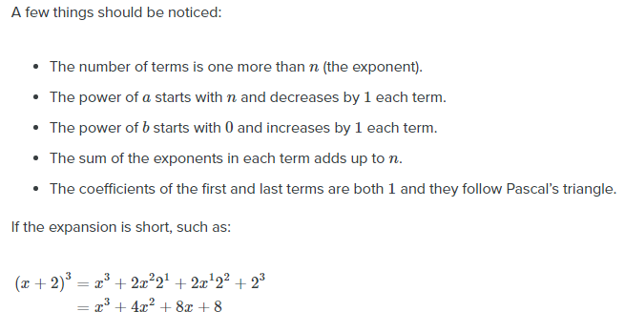

Multinomial:

The multinomial theorem provides a formula for expanding an expression such as (x1 + x2 +⋯+ xk)n for [integer](https://www.britannica.com/science/integer) values of n. In particular, the expansion is given by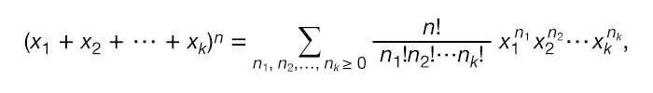where n1 + n2 +⋯+ nk = n and n! is the [factorial](https://www.britannica.com/science/factorial) notation for 1 × 2 × 3 ×⋯× n.

For example, the expansion of (x1 + x2 + x3)3 is x13 + 3x12x2 + 3x12x3 + 3x1x22 + 3x1x32 + 6x1x2x3 + x23 + 3x22x3 + 3x2x32 + x33.

**Coefficients:**

In algebra, one of the first things you learn how to do is read algebraic equations. An algebraic equation consists of a number of terms added and/or subtracted together. Each of these terms has two parts to it: variables and coefficients.

|  |
| --- |
| diagram of an algebraic equation |
| ***This diagram shows the difference between terms, coefficients, and variables in an equation.*** |

In statistics, we are introduced to a new type of coefficient known as the multinomial coefficient. In this lesson, you will learn what a multinomial coefficient is and how it is used in statistics.

**Multinomial Coefficient**

The multinomial coefficient gets its name from the multinomial series raised to the *n*th power, as seen below.

|  |
| --- |
| multinomial series |

In a series like this, the *x*'s represent terms, the *k* represents the number of elements in the series, and *n* is the positive integer power to which the series is raised. How a series like this is expanded is told to us by the **multinomial theorem**.

|  |
| --- |
| multinomial theorem |

In the multinomial theorem, the sum is taken over *n*1, *n*2, ... ,*n*k such that *n*1 + *n*2 + ... + *n*k = *n*.

The multinomial theorem gives us a sum of multinomial coefficients multiplied by variables. In other words, it represents an expanded series where each term in it has its own associated multinomial coefficient. The **multinomial coefficient** itself is expressed in terms of factorials.

|  |
| --- |
| multinomial coefficient |

**Multinomial Coefficient Example 1**

To better understand how the multinomial coefficient works, let's work though an example together where we find the multinomial coefficient of one term of an expanded multinomial series.

Given the following multinomial series:

|  |
| --- |
| multinomial series example |

What is the coefficient of the *a*3*c*2 term in the expanded series?

In order to solve this problem we'll be working with the multinomial theorem.

|  |
| --- |
| multinomial series expansion |

Starting by comparing the series in this problem to the left side of the multinomial theorem equation, we can see that *x*1 = *a*, *x*2 = 2*b*, *x*3 = 3*c*, and *n* = 5.

|  |
| --- |
| multinomial coefficient problem part1 |

Here, *k* = 3 since there are 3 elements (*a*, *b*, *c*) in the series. This is the formula for the full expansion of our series, but we're only looking for the coefficient of one term of the series. To do this, we're going to look at the right side of the equation without the sum, and identify *n*1, *n*2, and *n*3.

These values of *n* are given by the powers in our given term *a*3*c*2. The *a* is raised to the third power, which gives us *n*1 = 3, and *c* is raised to the second power, giving us *n*3 = 2.

We see *b* is absent in this term. This is the equivalent of *b*x = 1, which occurs when *x* = 0. Therefore, *n*2 = 0.

With all the values of *n* found, we now have everything we need to find the coefficient *a*3*c*2.

|  |
| --- |
| multinomial coefficient example part2 |

First, we write the multinomial coefficient out as factorials.

|  |
| --- |
| multinomial coefficient example part3 |

Then, all that's left to do is work out the basic arithmetic.

|  |
| --- |
| multinomial coefficient example final |

With this we've found that the coefficient of *a*3*c*2 is 90.